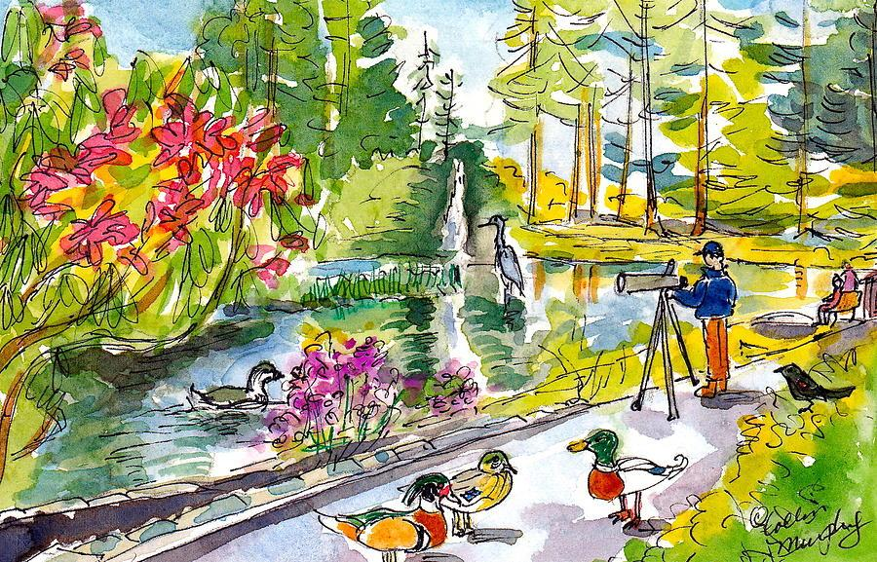

Spring Intensive Catalog

2023/24

Polaris K-12 School

May 6-17, 2024

(Secondary May 6-22)

Intensives are a pillar of the Polaris Academic program– they offer a unique opportunity for teachers and students to learn and engage in new experiences, lessons, and activities while also providing a chance to dive deeper into content then our traditional core classes allow. Our upcoming Spring Intensives will take the place of regular classes starting on Monday, May 6th. Intensives will run until to Friday, May 17th for our elementary students and until May 22nd for our Secondary students. Please read through this catalog to preview our intensive course offerings and complete the registration process via the [Intensive Registration Google Doc [Linked Here]](https://docs.google.com/forms/d/e/1FAIpQLScqjeYUFHhO8uiIYTquwWjfWlc5513Lkv2dpviK_mJ5LsR6Hw/viewform?usp=sf_link).

Because there are a limited number of seats available in each class, it is necessary for all students to select three (3) different choices, as prompted in the registration form. All registrations received by March 18th will be given equal consideration.

**The deadline for all intensive registration requests is March 18th at 5PM.**

Intensive confirmations will be available to view on March 22nd via Parent/Student Connect. All elementary students will also receive a paper confirmation in their family group that same day.

**Once you receive your Intensive confirmation, associated fees can be paid online via** [**ParentConnect**](https://parentconnect.asdk12.org/)**.**

**Fees must be paid by Friday, April 12th to reserve your child’s spot in their confirmed intensive.**

*Any student without intensive payment as of the first day of intensives will not be able to attend their intensive class until payment is received.*

If your family needs financial assistance to cover or offset the cost associated with a given intensive, please fill out the [Intensive Scholarship Application [Linked here]](https://docs.google.com/forms/d/e/1FAIpQLSdURyYZpo3hkw6UiK74YgCV0gYj_EO3Py2Zq1TAN9trZBO9_Q/viewform?usp=sf_link). Our school and our Polaris PTA works hard to raise scholarship money to provide equal access for all students to any given intensive. Please note, for intensives with large monetary costs, partial scholarships will be considered, but full scholarships are unlikely to be available in order to help support as many students/families as possible.

**Scholarship applications are due Wednesday April 3rd by 8:30AM.**

*Secondary Students–* If you are interested in taking an Intensive that is not in your grade-level range, you may write a letter to the Intensive teacher explaining why you want to take that particular course offering and why you feel you are qualified. If there is room in the course, the teacher will work with you and your family to accommodate your request.

Elementary Intensive Offerings:

| At a Glance:   * **Alphabet Adventures** (K-1) * **All About Books** (K-2) * **Dancing** (K-2) * **Ocean Animals** (K-2) * **Happy Brains, Happy Bodies** (2-5) * **The Wild Wonderful World of Trees** (2-12) * **Unicycling** (2-5) * **Art & Science** (3-5) * **Spring into Rm. 225** (3-5) |
| --- |

**Alphabet Adventures | K-1**

Are you ready to increase your reading skills while strengthening your letter and sound knowledge? We will build our literacy skills in many different ways including crafting, playing games, using Boost, trying Reader’s Theater, dramatic play and daily writing. Join us for a creative adventure and build your literacy skills at the same time! Students will need to bring their own headphones.

**Teacher: Marie Lacher, K/1 Teacher**

**Grade Levels: K-1**

**Fee: $10**

**All About Books | K-2**

If surrounding yourself with wonderful stories, building book forts and reading under trees sounds like fun, join Rachel in the library for All About Books! Each day brings a new children's author with fun filled activities, games, cooking (green eggs and ham anyone?) and celebrating books! From planting seeds with Eric Carle, elaborate pastries with Fancy Nancy to solving mysteries with Scooby Doo- full days and a fun time are in the pages of this intensive!

**Teacher: Rachel Gregory, Polaris Librarian**

**Grade Levels: K-2**

**Fee: $40**



**Dancing | K-2**

Do you like to move it, move it? Then this is the intensive for you! Dance your way through the eras in Teagen’s Dancing Intensive.

**Teacher: Teagen Stewart, K/1 Teacher**

**Grade Levels: K-2**

**Fee: $20**

**Ocean Animals | K-2**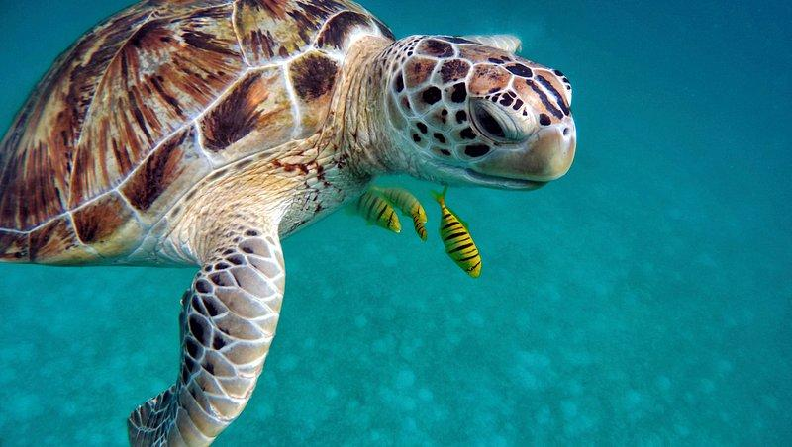

Calling all marine biologists! Come join the Ocean Animals Intensive for two weeks of under the sea fun! We will learn about a variety of ocean animals, create reports, make art projects, and read books all about our favorite marine wildlife. Hope to see you there!

**Teacher: Sarah Ottum, 2/3 Teacher**

**Grade Levels: K-2**

**Fee: $25**



**Happy Brains, Happy Bodies** **| 2-5**

Wintertime blues got you down? Join my intensive to learn ways to keep your brain and body happy and healthy! From hiking and swimming, to playing games and making nutritious food to eat, we’ll be building an extensive list of ways to take care of yourself, even during your hardest of days. Mindfulness, self care, and positive thinking will guide us through each day of adventure! *This intensive will require chaperones for field trips. Please ensure that you are able to help support us in these experiences!*

**Teacher: Tess Vandiver, 2/3 Teacher**

**Grade Levels: 2-5**

**Fee: $20**



**The Wild Wonderful World of Trees | 2-12**

We’re going to investigate trees – and learn about nature – through science and art.

This elementary, middle, and high school intensive will have multiple field trips, and we will need parent volunteers. From the UAF Cooperative Extension Service we will learn about invasive species and forest health (spruce beetle, and other insects/diseases of trees). We will become citizen scientists and assess tree height/maturity and when things green up. Students will hypothesize about what greens up first based on tree species, snow depth, snow compaction and collect and analyze the data.

We are going to partner with the Anchorage Botanical Garden to learn tree species, how trees grow, the roles trees play in ecosystems, and the ways in which trees and humans interact. As the intensive wraps, we are going to curate our treemendous experiences into art and poetry projects. Spruce up your science, writing, and art skills in this fun intensive!

**Teacher(s): Kyla Wilkinson, 2/3 Teacher & Mindi Vogel, Secondary ELA Teacher**

**Grade Levels: 2-12**

**Fee: $30**

**Unicycling | 2-5**

Have you ever seen somebody ride a unicycle? It is impressive! Have you ever wondered if *you* could learn to ride a unicycle? It IS harder than it looks, but you CAN learn to do it!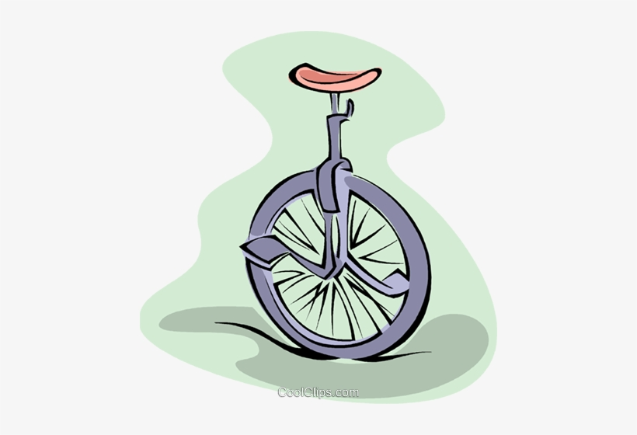

If you are a beginner who is interested in learning how to ride, this intensive will get you rolling. Unicycling will not only increase your core strength, coordination, and balance skills, but it will also increase your mental stamina and focus. The skills and techniques required for unicycling are most successful when they are practiced within a community of learners, who inspire and teach each other. It usually takes 15 to 40 hours of practice to master the skill and we will be on the unicycles every day. In addition, we will engage in a variety of balance and core exercises. Students are required to bring their own helmet every day of this intensive.

(Growth mindset) + (Hours of intentional practice) = (Riding a unicycle)

**Teacher: Arika Drake, 4/5 Teacher**

**Grade Levels: 2-5**

**Fee: $40**

**Art & Science | 3-5**

In this intensive, you will participate in various art and science projects! From bridge building, to clay sculptures, to bubble painting, we will have fun doing projects inside and outside using your creativity and problem solving skills.

**Teacher: Zada Maruskie, 4/5 Teacher**

**Grade Levels: 3-5**

**Fee: $30**

**Spring into Rm. 225 | 3-5**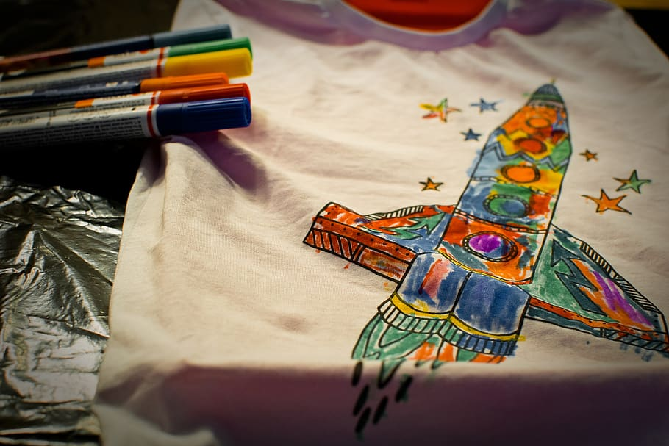

Every day will have open choices of art activities, crafts, building, writing, reading and games. Please come and join me as we finish out our year together. I’m excited to have you!

*We might get messy, so please come to school with appropriate clothing that you do not mind getting paint, glue or dirt on.*

**Teacher: Keana Graves, 4/5 Teacher**

**Grade Levels: 3-5**

**Fee: $30**

*Volunteers are welcome to join!*

Secondary Intensive Offerings:

| At a Glance:   * **Radio Science** (6-12) * **Salt, Fat, Acid, & Heat** (6-12) * **Let’s Golf!** (6-12) * **The Wild Wonderful World of Trees** (2-12) * **Board Gaming** (6-12) * **SPRING into Algebra** (7/8; 6th by invitation) * **Outdoor Adventure** **Alaska** (8-12) * **The Sound of Lyrics** (8-12) * **Next Level Papier-Mache** (8-12) * **Find Your Future** (11-12) * **Bike Anchorage** (6-12) |
| --- |



**Radio Science | 6-12**

Unleash the power of radio with the Radio Science intensive course! Explore the fascinating world of radio technology, from everyday devices to building your own circuits. Join us in partnership with the Anchorage Amateur Radio Club for hands-on experience, including training for the Amateur Radio Technician License examination and earning your license. Dive into the heart of communication at the Radio Science Operations Center (RSOC), where emergency services and cutting-edge technology converge. Don't miss your chance to connect, learn, and transform your understanding of radio science!

**Teacher: Adam Stewart, Secondary Orchestra Teacher**

**Course name/Credit: .5 Applied Technology (science elective)**

**Grade Levels: 6-12**

**Fee: $50**

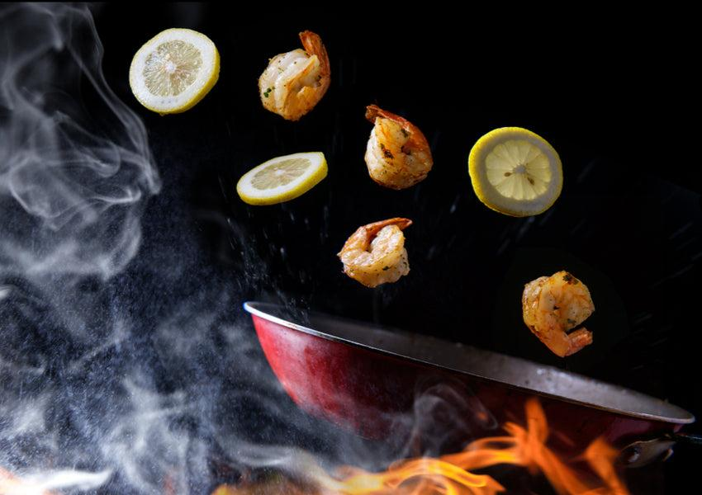

**Salt, Fat, Acid, Heat | 6-12**

Play with your food! Apply a few simple guidelines as you learn to cook just about anything, even if you don’t have a recipe. We’ll spend the first week learning basic concepts and techniques as we prepare meals for our lunches. The second week we’ll take a more experimental approach to our cooking as we introduce more variety and challenge students with unfamiliar ingredients. Dishes will be mostly vegetarian as students learn how to prepare healthy, inexpensive meals that taste great. Throughout, we’ll take the occasional opportunity to write about our experiences. With parental support, we can take a field trip to a local grocery store and explore how stores are organized and how foods are marketed.

**Teacher: Bryan Smith, Secondary Science Teacher**

**Course name/Credit: .5 Food Science (science elective)**

**Grade Levels: 6-12**

**Fee: $70**

**Let's Golf! (Traditional, Miniature and Disc) | 6-12**

We will learn proper technique, rules and etiquette of both traditional and disc golf. Local golf pros will provide off-site instruction for students. I will provide additional instruction to practice these skills here at Polaris, where we will also flex our creativity by constructing our own miniature golf course. This intensive is perfect for students who have an interest in golf and want to develop basic skills or for more experienced players who want to improve their game and take it to the next level. This intensive will require some parent/guardian assistance in transporting students to/from offsite locations and/or picking up and dropping off at offsite locations. I'm very excited to get outside with all the Polaris golfers and have fun improving each day!

**Teacher: Greg Hobson, K-12 PE Coach**

**Course Name/Credit: .5 Individual Rec Activities (PE Elective)**

**Grade Levels: 6-12**

**Cost: $90**

**The Wild Wonderful World of Trees | 2-12**

We’re going to investigate trees – and learn about nature – through science and art.

This elementary, middle, and high school intensive will have multiple field trips, and we will need parent volunteers. From the UAF Cooperative Extension Service we will learn about invasive species and forest health (spruce beetle, and other insects/diseases of trees). We will become citizen scientists and assess tree height/maturity and when things green up. Students will hypothesize about what greens up first based on tree species, snow depth, snow compaction and collect and analyze the data.

Secondary students will have the opportunity to explore forest careers. And we are going to partner with the Anchorage Botanical Garden to learn tree species, how trees grow, the roles trees play in ecosystems, and the ways in which trees and humans interact. As the intensive wraps, we are going to curate our treemendous experiences into art and poetry projects. Spruce up your science, writing, and art skills in this fun intensive!

**Teacher(s): Mindi Vogel, Secondary ELA Teacher & Kyla Wilkinson, 2/3 Teacher**

**Course name/Credit: .25 Poetry (LA Elective), .25 Environmental Issues (Science Elective)**

**Grade Levels: 2-12**

**Fee: $30**

**Board Gaming | 7-12**

Command grand armies of the Republic or raise up levies to defend the homeland. In Strategy Board Gaming, you will have the opportunity to gain a deeper understanding of logistics and conflict. Command armies such as those of Zenobia or Boudicca, reenact Sherman’s campaign of total war or lead Hannibal’s armies to the gates of Rome! Understand the link between industrial production and the United State's ultimate victory in WW II. With strategy board gaming, the choice is yours…

Examples of games that we currently have: Risk, Axis and Allies, Settlers of Catan & Stratego.

**Teacher(s): Jeff Bevier & Larry Frick; Secondary Social Studies Teachers**

**Course name/Credit: .5 Social Studies Special Topics (Social Studies Elective)**

**Fee: $10**

**SPRING into Algebra | 7/8; 6th grade by invitation**

In this intensive students will focus on the following areas: (1) Developing an understanding of operations with rational numbers, (2) Evaluating and solving expressions and equations, (3) Developing understanding of proportional relationships: To include graphing and solving linear equations with and without functions, (4) Understanding and applying Area and Volume Formulas: To include the Pythagorean Theorem, squares and square roots, and (5) If time permits, we will have fun with probability.

**Teacher: Akara Anglin, Secondary Math Teacher**

**Course Name: Math Special Topics**

**Grade Levels: 7/8; 6th by invitation only**

**Fee: $30**

**Outdoor Adventure Alaska | 8-12**

***May***, a time of year when Spring is in full bloom, beckons us outdoors! Join us for an unforgettable adventure in our stunning Alaskan landscape. Our journey will take us hiking across the majestic terrains of Flat Top, Bird Ridge, and North Face, among others. We'll engage in exhilarating activities like Frisbee golf at Kincaid and geocaching, topped off with delightful picnics. Our grand finale? A camping trip at Eklutna where we'll immerse ourselves in the great Alaskan outdoors. You will get your exercise! Good shoes and a positive mindset are pre-requisite 🙂 ***Families are required to participate in driving. Chaperones are needed for camping at Eklutna May 20-21.***

**Teacher: Andrea Evans, Secondary Science Teacher**

**Course Name/Credit: .5 Outdoor Adventure (PE Elective)**

**Grade Levels: 8-12**

**Fee: $100**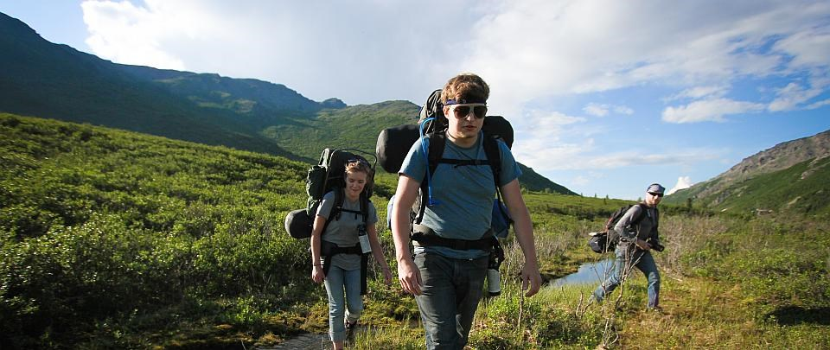

**The Sound of Lyrics: Lyrical Analysis & Lyric Writing | 8-12**

Are you passionate about music? Are you interested in studying your favorite songs on a deeper level? Have you ever had an interest in writing your own song lyrics or perhaps already attempted to write your own lyrics? Do you just enjoy writing or a "good" song? 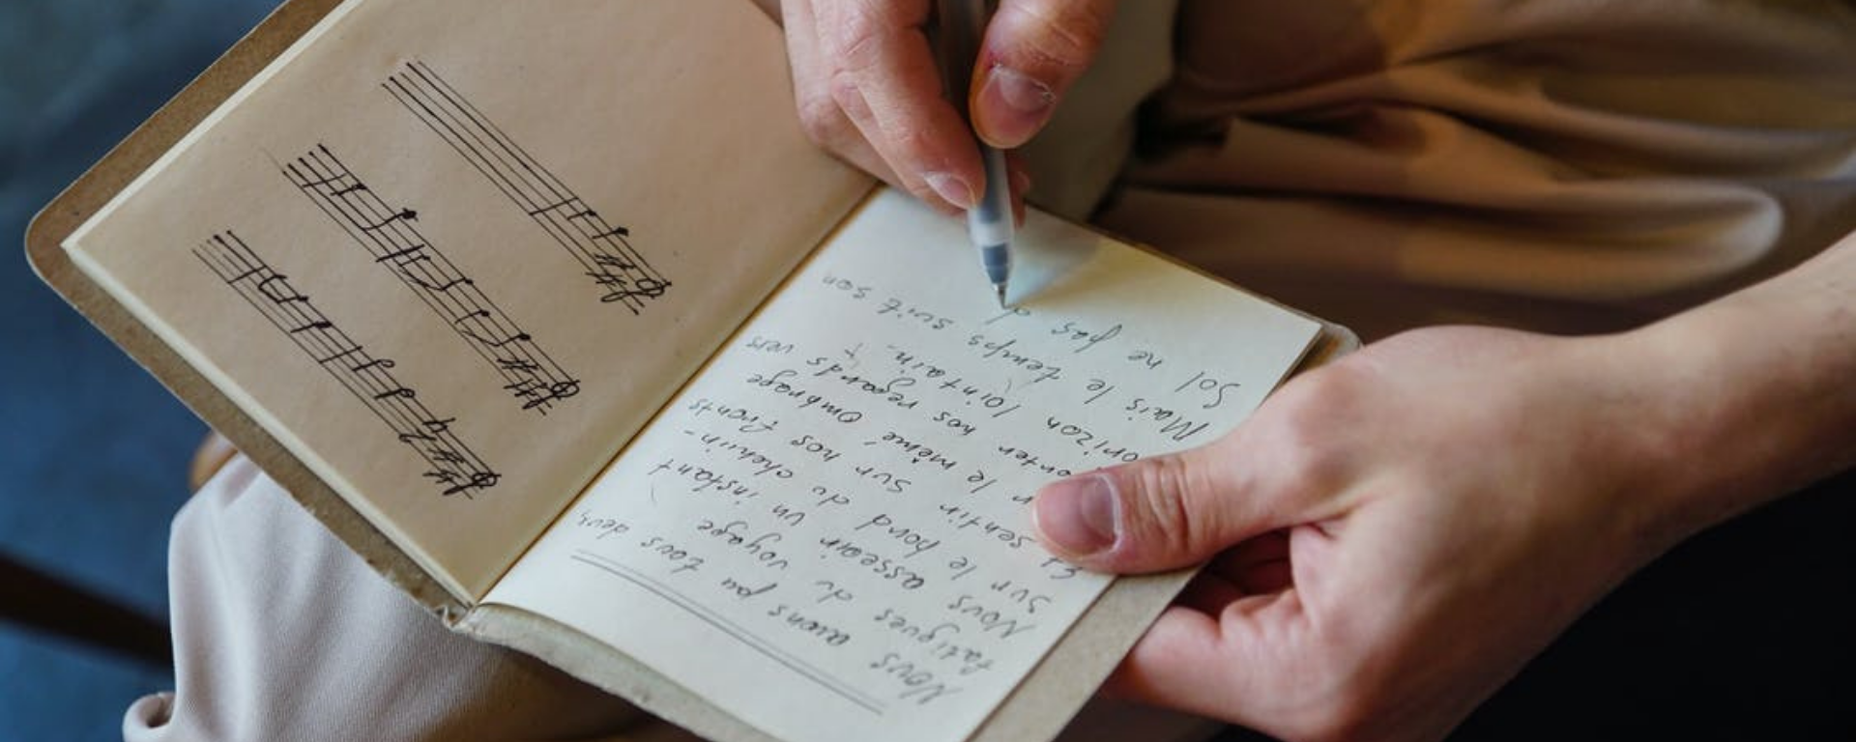

If so, please join us for a lyrical analysis and lyric writing intensive this spring. We'll be studying lyrics from an array of songs across multiple genres (including your favorites), as well as writing lyrics to your very own song.

**Teacher: Andrew Mullins, Secondary English Teacher**

**Course name/Credit: .5 Poetry (LA Elective)**

**Grade Levels: 8-12**

**Fee: $20**

**Next Level Papier-Mache | 8-12**

Papier-mâché is commonly thought of as an elementary craft, however it is possible to create very sophisticated and large scale sculptures with the technique. It’s used in carnival floats, costuming and theater, as well as architectural decoration. We’ll explore the more grown-up side of the craft, along with history, advanced techniques, tools, and materials.

**Teacher: Kelly Hebert, K-12 Art Teacher**

**Credit: .5 Art Special Topics (elective)**

**Grade Levels: 8-12**

**Fee: $30**

**Find Your Future | 11-12**

This Intensive gives you the time and skills to develop a *solid plan* for your final year of high school and your first year of college, the work world, or the military. This Intensive is for EVERYONE in 11th grade - and 12th graders who haven’t taken it yet. Get a head start and a competitive edge on scholarships, admissions, resume writing, securing internships, and preparing for the work world. Develop a *professional quality digital scholarship portfolio* and a *personal action plan* with your goals and objectives listed by date. Hear from professional financial advisors, state financial aid counselors, admissions counselors, and former Polarians that are currently attending schools all over the country. This is the place to ask the questions that you have about how it all works after high school, regardless of the direction you are headed. You will also be given the opportunity to take a practice SAT or ACT test with Frontier Tutoring here at Polaris. They will provide you with a detailed score report that highlights trends and patterns in your performance. Single class enrollments at other schools will be accommodated for this Intensive. Please check in with Allie as soon as possible if that applies to you.

**Teacher: Allie Burris, Secondary Social Studies Teacher**

**Course Name/Credit: .25 Individualized Writing (LA Elective) .25 Computer Fund. (elective)**

**Grades: 11-12**

**Fee: None**



**Bike Anchorage 2024**

*Spring Intensive • May 6 - 22, 2024*



Join us on an epic adventure as we explore Anchorage’s extensive bike trail system on two wheels. We will be covering basic bike maintenance, shared trail etiquette and safety, and day trip packing and nutrition with various guest speakers. Be prepared to RIDE! Last year we logged an impressive 192.17 miles. We will begin with a few moderate rides and our bike mileage will increase daily, with an end goal of biking THE MOOSE LOOP.

Safety is our number one priority. Students are expected to adhere to all ASD behavior expectations on and off campus AND any additional safety regulations put in place to ensure the safety of the individual and the group. Disregard for personal/group safety will result in immediate action, likely resulting in removal from the intensive. We want this to be a safe and positive experience for everyone!

We are excited to be partnering again with Anchorage Parks & Recreation to bring a service learning component to our intensive as we work collaboratively in city-wide clean-up efforts.

**Required equipment:** Bike with gears *(good working order and tuned up)*

Helmet *(mandatory ANY time a student is on a bike)*

Day/backpack with lunch/snacks/water

Weather-appropriate clothing *(moisture wicking and layers)*

Well-fitting bike appropriate shoes *(no sandals!)*

**Optional, but recommended:** Spare tube/tire; patch kit

Hydration pack or water bottle with frame cage

Small first aid kit

High visibility clothing/reflectors

Gloves (preferably biking gloves)

Eye protection *(sunglasses/clear lenses)*

**Optional, for comfort:** Padded bike shorts/tights

Wicking jersey or top

**Teachers:** **Christian Haich** [Haich_Christian@asdk12.org](mailto:Haich_Christian@asdk12.org)

**Heidi Postishek** [Postishek_Heidi@asdk12.org](mailto:Postishek_Heidi@asdk12.org)

**Course Name/Credit: .5 Individual Rec Activities (PE Elective)**

**Grades: 6-12**

**Fee:** **None; See required and suggested equipment**